Step-by-Step Instructions
Step 1: Organize your Raw Clean Data
Before running the augmentation script, you must organize your clean synthetic images (generated in Week 2) into class folders.
Create this exact structure in your project root:
Text
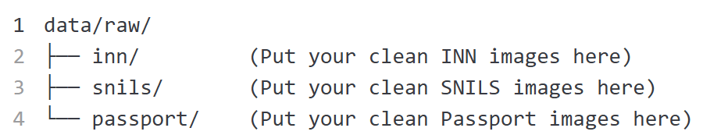
- In-Class Demo: Place 5 images per folder to test the pipeline quickly.
- Homework 3 Target: You will eventually need 100 to 300 images per folder.
Step 2: Understand the Augmentation Rules
As an AI Data Engineer, you must understand the difference between Orientation and Quality.
Class | Definition | Allowed Augmentations
GOOD | Text is sharp and readable. The OCR engine can read it, even if the phone was held at an angle. | Slight rotation (±8°), Upside down (180°), 90°/270° rotation, Clean (None).
BAD | Text is destroyed or hidden. The OCR engine will fail. | Gaussian Blur, Glare (white overlays), Strong Skew (±30°), Occlusion (black shapes/fingers), Bad Exposure (too dark/bright).

Project Manager's Note: Do NOT use horizontal/vertical flipping. Mirroring text creates fake languages and unrealistic document layouts!
Step 3: Run the Pipeline Script
Use the provided build_good_bad_dataset.py script.
For the Full Homework (e.g., you have 100 raw images but want 300 per class):
Step 4: Audit and Verify (Crucial PM Step!)
Do not just run the code and assume it works. A good AI Project Manager audits the data.
- Open the good/ folder. Are the images actually readable? Are some upsides down? (They should be!).
- Open the bad/ folder. Can you see the 5 different defects (blur, glare, skew, occlusion, exposure)?
- Open summary.json. Check if the classes are perfectly balanced.
- Open metadata.jsonl. Verify that the split (train/val/test) is assigned by source image to prevent data leakage.

